Rule Change Request Document

Name: | Nikki Carter |  | Country: | Chairman

Summary of Change Requested:
To specify what sorts of leg supports can be used by riders

Current Rule Book Wording:
None

Suggested New Rule Book Wording:
- GR5.7. No rider may wear a knee or other limb support device that has external solid fittings unless it is securely covered by neoprene or other similar padding material.

Reason for Change Request:
Many riders use knee supports – either as protection against hitting poles or to support or prevent knee injuries.

Some knee supports have exterior metal fames that could injure any rider or pony coming into close contact with them and which also have gaps between the frame and the rider’s leg which could trap equipment, a finger/hand or part of another pony’s tack

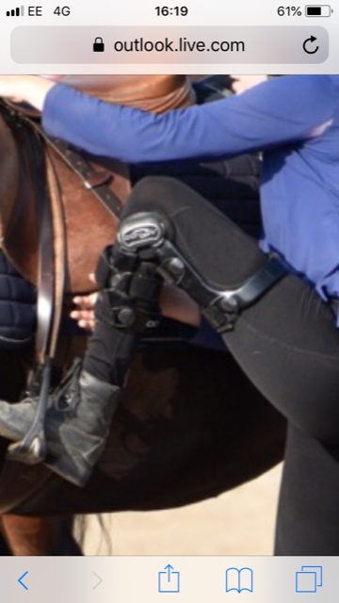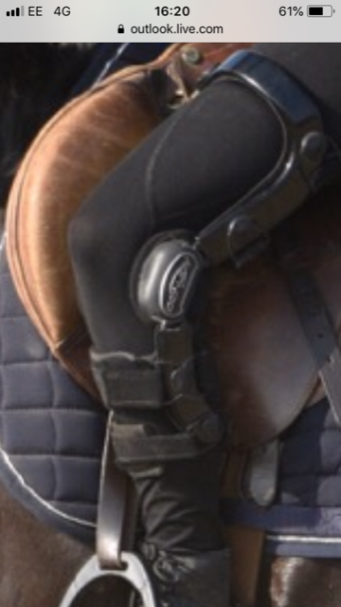

For Internal Use Only:

Reference: | 2019 – 01

Submission Date: | 11/12/2018

Decision Date: | 12/12/2018

Votes
Jens Martin | In Favour
Nikki Carter | In Favour
Iain Hopkins | In Favour
Brian Kennedy | In Favour
Margaret Welsby | In Favour
Alun Whitney | In Favour
Total In Favour: | 6
Total Not In Favour: | 0

Result: | Change Accepted

Actual Adopted New Rule Book Wording:
GR5.7. No rider may wear a knee or other limb support device that has external solid fittings unless it is securely covered by neoprene or other similar padding material.

Reason for Decision:
Important for reasons of safety.

Implementation Date: | 1st January 2020

